**IS YOUR HEART HEALTHY ??**

**Cardiovascular Disease Prediction Portal**

***Jyoti Thakur, Rishabh Kumar, Saksham Vashistha, Shivam Sharma***

Department of CSE, ABESIT, Ghaziabad, India

**Abstract**

The goal of this Research Paper is to provide an Online Cardiovascular disease prediction portal. The portal provides users a platform where they can find out Are there any chances of having a heart disease or not. This Portal can only predict, that user is suffering from any Cardiovascular disease or not. The Prediction model is developed by using Logistic Regression Algorithm. The portal is easy to use and made completely user-friendly.

**Introduction**

In this modern world, we humans are trying to make our life to live comfortably, but most of us don’t know about ourself Is he/she healthy or not. We are trying to live our life comfortably but not healthy which are two different things. Technology and Machines made it easier but it also affects nature. From last few years, all countries are trying to reduce these effects on nature. But still, Humans has more chances of having disease from that. As Heart is main Component of our Body and there is high risk of having Heart Diseases from Pollution. That’s why we made this Prediction Portal in which users can check easily for their heart disease. The Prediction Model uses basic input features like Age, Height, Weight, Blood Pressure, Cholesterol, Glucose, Smoking, Alcohol, and gives output as Yes or No for Cardiovascular Disease.

**Logistic Regression :-**

This is a Supervised Machine Learning Algorithm, which is used to solve (predict) binary classification Problems. The dataset we used is based on binary classification, which targets to a value lies between 0 and 1 [Binary Values].

**Django :-**

Django, It is Python Programming language based framework used to develop Web Applications.

**Google Map API :-**

The Google Map API used in this Project will show the data of Best Heart Hospitals across the World. This will perform two functions: first, it will return Google Maps for user and second, it will show the address of Best Heart hospitals.

**METHODOLOGY**

The Prediction is not based on any symptoms or effects. User can check anytime for their health. OR, we suggest to check twice or thrice in a year after performing a regular body check-up. As, prediction uses some examination features too like, Blood Pressure (Systolic & Diastolic), Cholesterol and Glucose. The portal wasn’t storing any data of user. As soon as user provides inputs to the Application, the App will provide the features to the created model and fetch the result as Healthy or Not healthy. The Disease or symptoms related to any, and Contacts of the physicians will be added in future.

**The Application consist of Multiple Tabs:**

**Home**

Homepage Consists of Basic Information[Fig. 3], Prediction Page[Fig. 4], and BMI Calculator [Fig. 5]. From the top of the homepage, user can visit World’s 3 Best Hospitals provided in carousel format. And mid section contains Prediction portal says, “Are You Healthy Enough?”, user can visit the portal using check button. and the last section contains BMI Calculator which will show your BMI Report in format of a progress bar.



**Fig. 3: Homepage**

Prediction Page:- User can fill up their information and check, Is he/she healthy by heart or not. By providing some basic features like, age, height, weight, BP, cholesterol, and glucose.

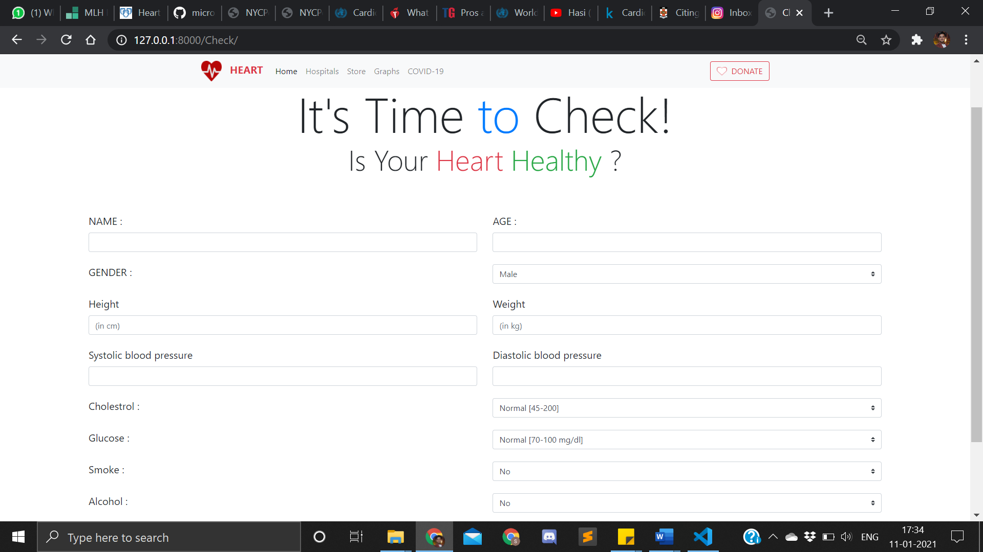

**Fig. 4: Prediction Page**

BMI (Body Mass Index):- BMI can help humans to check the percentage of fat or tissues mass on their body by providing their height and weight, the value obtained from calculation is used to categorize whether a person is Underweight, Normal, Overweight, or Obese depending on range specified.

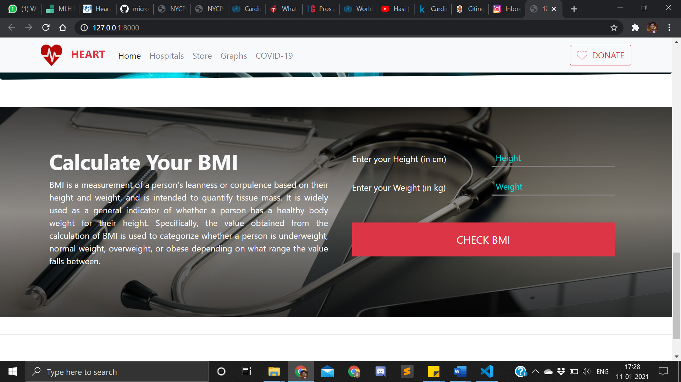

**Fig. 5: BMI Calculator**

**Hospitals**

In this section, multiple hospitals data are provided in .json file and shown on google maps using Google Maps API [Fig. 6]. User can view full address of any Hospital by just hovering the cursor over any marker.

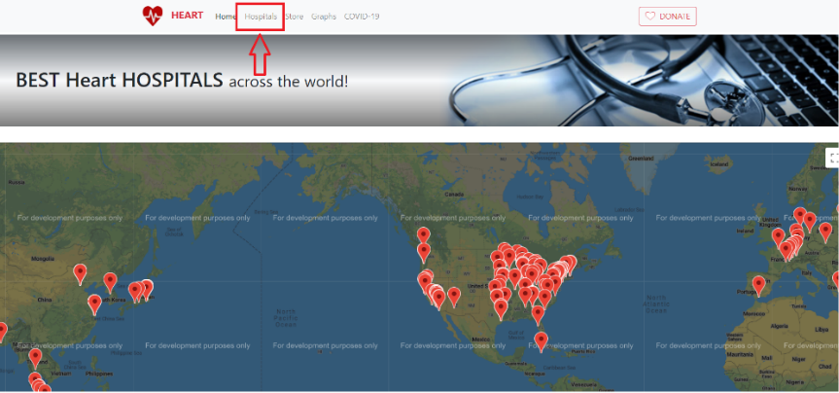

**Fig. 6: Best Hospital over world**

**Graph**

In this Section, user can check population rates (growth & death rates) of different countries of over past 70 years. The datasets are provided in backend and final graph is plotted using python-library, Matplotlib [Fig. 7], which is overplotted on same image every time user changes parameters.

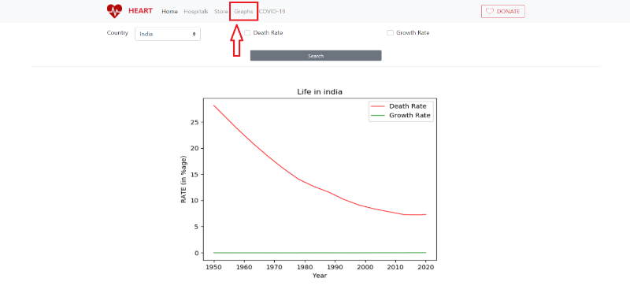

**Fig. 7: Population Graph**

|  |  |  |  |  |  |  |  |  |  |  |
| --- | --- | --- | --- | --- | --- | --- | --- | --- | --- | --- |
| age | **gender** | **height** | **weight** | **ap_hi** | **ap_lo** | **cholesterol** | **gluc** | **smoke** | **alco** | **cardio** |
| 18393 | 2 | 168 | 62 | 110 | 80 | 1 | 1 | 0 | 0 | 0 |
| 20228 | 1 | 156 | 85 | 140 | 90 | 3 | 1 | 0 | 0 | 1 |
| 18857 | 1 | 165 | 64 | 130 | 70 | 3 | 1 | 0 | 0 | 1 |
| 17623 | 2 | 169 | 82 | 150 | 100 | 1 | 1 | 0 | 0 | 1 |
| 17474 | 1 | 156 | 56 | 100 | 60 | 1 | 1 | 0 | 0 | 0 |
| 21914 | 1 | 151 | 67 | 120 | 80 | 2 | 2 | 0 | 0 | 0 |
| 22113 | 1 | 157 | 93 | 130 | 80 | 3 | 1 | 0 | 0 | 0 |
| 22584 | 2 | 178 | 95 | 130 | 90 | 3 | 3 | 0 | 0 | 1 |
| 17668 | 1 | 158 | 71 | 110 | 70 | 1 | 1 | 0 | 0 | 0 |
| 19834 | 1 | 164 | 68 | 110 | 60 | 1 | 1 | 0 | 0 | 0 |
| 22530 | 1 | 169 | 80 | 120 | 80 | 1 | 1 | 0 | 0 | 0 |
| 18815 | 2 | 173 | 60 | 120 | 80 | 1 | 1 | 0 | 0 | 0 |
| 14791 | 2 | 165 | 60 | 120 | 80 | 1 | 1 | 0 | 0 | 0 |

**Fig. 2: Dataset of Provided Features**

**REFERENCES**

1. Aurélien Géron*, Hands-On Machine Learning with Scikit-Learn and TensorFlow,* California: O’Reilly Media, 2017.
2. Jason Brownlee, “*How to Make Predictions with scikit-learn*”, April 6, 2018, <https://machinelearningmastery.com/make-predictions-scikit-learn/>
3. CodeWithHarry, “*Python Django Tutorials*”, YouTube, Retrieved January 27, 2019, from <https://www.youtube.com/watch?v=5BDgKJFZMl8&list=PLu0W_9lII9ah7DDtYtflgwMwpT3xmjXY9/>
4. Svetlana Ulianova: Cardiovascular Disease Dataset, Jan 2019, Kaggle <https://www.kaggle.com/sulianova/cardiovascular-disease-dataset/>
5. Data Source: [United Nations - World Population Prospects](https://population.un.org/wpp/), “*Death Rate*” Retrieved September 16, 2020, Macrotrends <https://www.macrotrends.net/countries/IND/india/death-rate/>
6. Data Source: [United Nations - World Population Prospects](https://population.un.org/wpp/), “*Growth Rate*” Retrieved September 16, 2020, Macrotrends <https://www.macrotrends.net/countries/IND/india/birth-rate/>